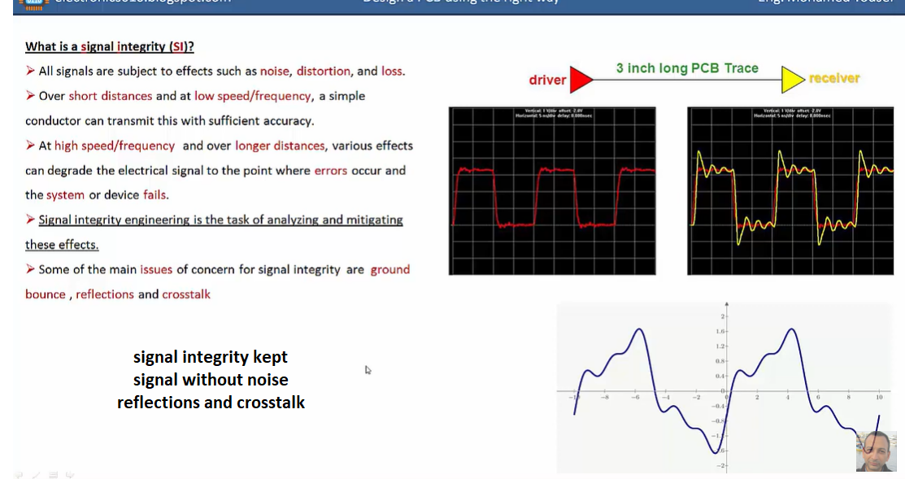**Signal integrity course Mahmoud Youssef**

